# Process Documentation

## Process Description

Here is the high level model captured by the interviews.

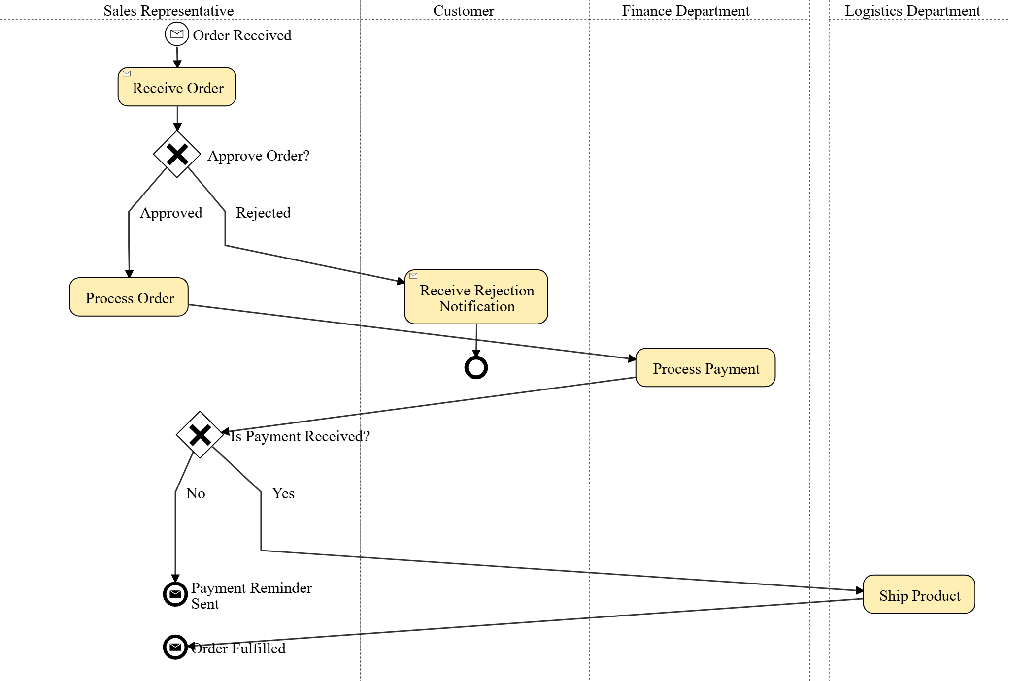

This section provides a high level description of the process flow...

The process begins with an initial inquiry or prompt to confirm readiness for process modeling. Once readiness is confirmed, the process proceeds to the modeling phase, where the specific steps and components of the process are identified and structured. This is followed by a review phase to ensure accuracy and completeness. Finally, the process concludes with the implementation or documentation of the modeled process.

## Process Detailed Description

Here is the more detailed model captured by the interviews.

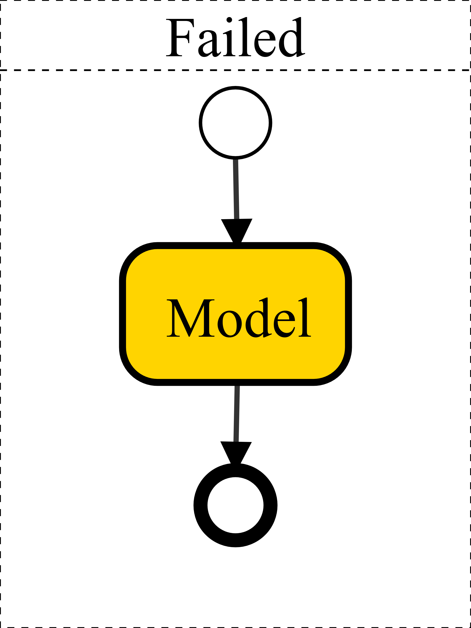

## Process Structured Documentation

This section provides a detailed description of the documented process...

Process Description:  
  
1. **Actors**: Identify all the participants involved in the process. These could be individuals, departments, or external entities that interact with the process. Examples include Customer, Sales Representative, and Supplier.  
  
2. **Tasks**: Define the specific activities or tasks that need to be performed within the process. Each task should have a clear objective and outcome. Examples include "Receive Order," "Process Payment," and "Ship Product."  
  
3. **Systems**: Identify any systems or software applications that are used to support the process. These could be ERP systems, CRM systems, or any other technology platforms. Examples include SAP, Salesforce, and Oracle.  
  
4. **Gateways**: Use gateways to represent decision points within the process where the flow can diverge or converge based on certain conditions. Examples include "Approve Order?" and "Is Payment Received?"  
  
5. **Sequence Flows**: Define the order in which tasks are performed and how the process flows from one task to the next. Use arrows to indicate the direction of the flow.  
  
6. **Events**: Identify any events that trigger the start or end of the process, or that occur during the process. Examples include "Order Received" and "Payment Confirmed."  
  
7. **Data Objects**: Represent any data or documents that are used or produced during the process. Examples include "Order Form," "Invoice," and "Shipping Label."  
  
8. **Swimlanes**: Use swimlanes to organize the process by actor or department, showing who is responsible for each task. This helps to clarify roles and responsibilities.  
  
9. **Annotations**: Add any additional information or notes that help to clarify the process or provide context. These can be used to explain complex tasks or decisions.  
  
10. **End Events**: Define the outcomes or results of the process, indicating how the process is completed. Examples include "Order Fulfilled" and "Payment Processed."

## Conversation with Domain Experts

This section provides a detailed description of the documented process...

Hello, are you ready to model your process? 👇

## Comments on the Mermaid Model

These are the feedback on the mermaid model